






Board of Education

Jeff N. Heiner, President Jennifer Zundel, Vice President
Douglas B. Barker
Don E. Belnap
Susan Richards
Joyce Wilson
Nancy Blair

Sandy Coroles, Superintendent
Zane K. Woolstenhulme, Business Administrator

Request for Proposals 7-006
Whole District Network Wiring upgrade

General Information

A. Purpose
Ogden City School District (the “District”) is accepting proposals from qualified reputable firms for network wiring and hardware installation that will meet our specifications listed below. Bids will be evaluated and each requirement will be scored. A higher emphasis will be placed on cost and reputation of the bidding company.

This RFP is designed to provide interested parties with sufficient basic information to submit proposals meeting minimum requirements, but is not intended to limit a proposal’s content or exclude any relevant or essential data. Respondents are at liberty and are encouraged to expand upon the specifications to evidence service capability under any agreement.

B. Background
Ogden City School District has a student enrollment of approximately 12,500 students. The District currently operates 14 elementary schools, three (3) Jr. High schools, two (2) high schools, and one (1) Alternative high school. District offices and support facilities are located at 1950 Monroe Blvd, Ogden, Utah.

C. General Requirements & Information
Vendor shall be a registered ERATE service provider and will provide their SPIN number as part of the bid process. Please enter this number in the “Executive Summary” section of the bid response. Vendor will have a Utah presence or will have previously done business with Ogden School District for bid to be considered. Winning vendor will do all work specified and will not sub-contract unless there is prior approval from District officials.

Awarding and funding of this RFP will be dependent on ERATE funding approval. The District reserves the right to cancel the RFP if ERATE funding is denied, not fully funded or District funds are unavailable.

All questions regarding this RFP will be submitted and responded to through SciQuest. Do not contact any District employee regarding this RFP. There will be a mandatory pre-bid walk-through for each location where building maps will be provided to those who attend. The walk-through dates are Thursday, March 16th from 12:00PM to 4:00PM and Friday, March 17th from 7:30AM to roughly 11:30AM and then restarting at 12:30PM to 4:00PM. The meeting on March 16th will start in the Training Conference Room in Building 11 of the District campus, 1950 Monroe Blvd. We will go over any general questions at that time and then begin the walk-though of a few locations. Remaining locations will be completed the next day at an agreed upon location. Only vendors that attend the walk-though will be eligible to submit an RFP.

All products offered in response to this solicitation shall be new, current and in ongoing production; shall have been formally announced for general marketing purposes, shall be a model or type currently functioning in a user (paying customer) environment, and capable of meeting or exceeding all specifications and requirements set forth in this solicitation. Used, refurbished, demo, prototype or gray market equipment will not be acceptable in this Bid. All products must be supplied through an authorized distribution channel. All products listed below are for reference only and any equal or greater product from any vendor can be substituted:

Scope of Work and Wiring Standards

Summary of Scope of work.

The contractor shall supply all labor and material for a complete functional system as described. It may include installing all cabling, conduit, surface molding, raceway, faceplates, boxes, wire management, patch panels, modular jacks, patch cables, racks, trenching and other labor related to the installation.

- Installation of 676 data drops consisting of 2 data lines in each drop. See maps for approximate locations. Exact location on the ceiling in each room will be determined by OSD Technology Department during installation.
- Installation of 63, 48 port patch panels and 63 horizontal wire management panels
- Installation of fiber and 2 access points to three press boxes including all fiber, copper and racks.
- Mounting, physical installation, patching, and removal of all access points according to each school map.
- 1900, 1 meter category 6 patch cables in light blue color
- 1900, 2 meter category 6 patch cables in light blue color
- 100, 2 meter SC-LC 50 Micron multimode patch cables in aqua color
- 20, 2 meter LC-LC 50 Micron multimode patch cables in aqua color
- Testing, documentation and warranty of the installed cabling system.

Copper Wiring Standards

- All copper will be Category 6, 450 MHz Plenum cable or better
- All copper patch cables will be Category 6, 450 MHz or better.
- All copper will be plenum rated
- Maximum horizontal run will be 295 feet
- Follow the EIA/TIA 568 standards per school
- All copper will be in conduit, raceway or molding if run in occupied areas
- All conduit, raceway or molding shall be secured. (IE...No peel and stick)
- Horizontal Cable support must be provided to specifications in tunnels or ceiling areas when necessary.
- All copper should terminate on a patch panel
- For every patch panel a horizontal wire management must be installed
- Mounting surface boxes or biscuit boxes and face plates are required and will be secured in occupied areas.
- Copper lines will be labeled both on the wire and the box
- 10’ service loop where possible on access point side
- A data drop is considered 2 separate data lines..
- All equipment locations specified by Ogden School District Technology Supervisor or Network Engineer only. No changes without their authorization.

Fiber Wiring Standards

- All fiber should be 50 micron(μm) OM4 multimode Plenum cable or better
- All fiber patch cables will be 50 micron(μm) OM4 multimode or better
- All fiber should be plenum rated
- All fiber should be in plenum rated inner duct as much as possible to protect fiber cable.
- All fiber inner duct will be secured where necessary
- Either a rack or wall mounted LIU for each termination point including inserts
- All ends should be terminated with SC or LC to match fiber LIU insert
- Fiber should be labeled on both the wire and the LIU
- 10’ service loop on each end
- All equipment locations specified by Ogden School District Technology Supervisor or Network Engineer only. No changes without their authorization.

New Rack Locations

- Wall mounted racks will be secured to the wall.
- Exact location of equipment within the building will be determined during install.

Types of Wiring Equipment Preferred

- Hubbell category 6 48 port patch panels or equivalent or better
- Hubbell Horizontal wire management or equivalent or better
- Hubbell category 6 modular jacks (Black) (keystone) or equivalent or better
- Fiber Patch cables will be Aqua in color (2 meter)
- Copper Patch cables will be Light Blue in color. (both 1 and 2 meter in length)
- Hubbell RE2 or equivalent
- Hubbell Fiber LIU both rack and wall mount or equivalent
- Hubbell Surface Raceway. All boxes, faceplates and other accessories must be compatible with other raceway/moulding per each school. Substitutions may be allowed by Ogden School District (OSD) Technology Supervisor or Network Engineer only. No changes without their authorization.

Detailed Scope of Work

Access Points Wiring and Installation

- Install data drop consisting of 2 data lines at each access point location to nearest rack location. See school maps.
- Contractor will install, mount, and patch in Access Point at each access point location. District will provide Access Point and Access point Mount. Contractor will need to provide screws or means to secure the mount to the ceiling
- Contractor will patch in access point on ceiling with two 1 meter cables in accordance and with direction from OSD Technology Department.
- Contractor will patch in two, 2 meter patch cables to patch panel in accordance and with direction from OSD Technology Department.
- Contractor will remove old Access points according to each school’s map.

Ogden High School Field Wiring

  - Fiber runs
    - Run 6 strand Fiber cable from School MDF to Baseball Pressbox
    - Run 6 strand Fiber cable from Baseball press box to Football press box
    - Pathway exists from School MDF to Baseball Press box. There is no pathway from Baseball Press Box to Football press box. Pathway will need to be trenched.
  - School MDF
    - Rack mounted LIU to support 6 strand fiber cable
    - SC or LC fiber inserts for all strands of fiber
  - Baseball press box will need
    - Wall mounted rack bolted to wall near power
    - Wall mounted Fiber LIU to support 2 6 strand fiber cables mounted either in or besides the rack
    - SC or LC fiber inserts for all strands of fiber
    - 24 port cat 6 450mhz or better patch panel
  - Football press box will need
    - Wall mounted rack bolted to wall near power
    - Wall mounted Fiber LIU to support 6 strand fiber cable mounted either in or besides the rack
    - SC or LC fiber inserts for all strands of fiber
    - 24 port cat 6 450mhz or better patch panel
    - Two Cat 6 450MHz or better cable to 2 ap locations at either end of the stadium in sealed conduit if running in weather exposed areas.
    - 6’ pole mounted/welded to top of stadium at north and south end
    - Weather tight box for data connections mounted near pole or on pole(see ap pic below)
    - Installation, mounting, patching of 2 outside access points.

Ben Lomond High School Field Wiring

  - Fiber runs
    - Run 6 strand Fiber cable from School MDF to football Pressbox
    - Pathway exists from School MDF to Building directly under Football Stadium. There is no pathway from the building under stadium to Football press box.
  - School MDF
    - Rack mounted LIU to support 6 strand fiber cable
    - inserts of either SC or LC for all strands of fiber
  - Football press box will need
    - Wall mounted rack bolted to wall near power
    - Wall mounted Fiber LIU to support 6 strand fiber cable mounted either in or besides the rack
    - SC or LC fiber inserts for all strands of fiber
    - 24 port cat 6 450mhz or better patch panel
    - Two Cat 6 450MHz or better cable to 2 ap locations at either end of the stadium in sealed conduit if running in weather exposed areas.
    - 6’ pole mounted/welded to top of stadium at north and south end
    - Weather tight box for data connections mounted near pole or on pole(see ap pic below)
    - Installation, mounting, patching of 2 outside access points.

District Soccer Campus Field Wiring

  - Fiber runs
    - Run 6 strand Fiber cable from Annex building to Soccer Storage Room
    - There is no pathway from Annex building to Soccer Storage Room. Pathway will need to be trenched.
  - Annex Building
    - Rack mounted LIU to support 6 strand fiber cable
    - inserts of either SC or LC for all strands of fiber
  - Soccer Storage Room
    - Wall mounted rack bolted to wall near power
    - Wall mounted Fiber LIU to support 6 strand fiber cable mounted either in or besides the rack
    - SC or LC fiber inserts for all strands of fiber
    - 24 port cat 6 450mhz or better patch panel
    - Two Cat 6 450MHz or better cable to 2 ap locations at either end of the concession/entrance building in sealed conduit if running in weather exposed areas.
    - Weather tight box for data connections mounted near pole or on pole(see ap pic below)
    - Installation, mounting, patching of 2 outside access points.

Ogden Field Installation Map

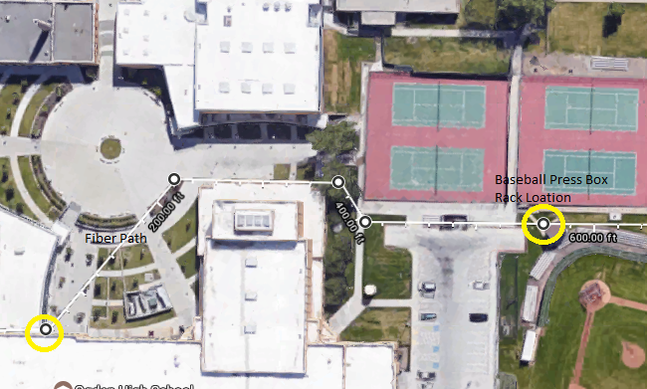

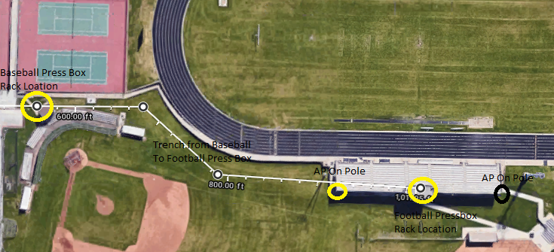

Ben Lomond Field Installation Map
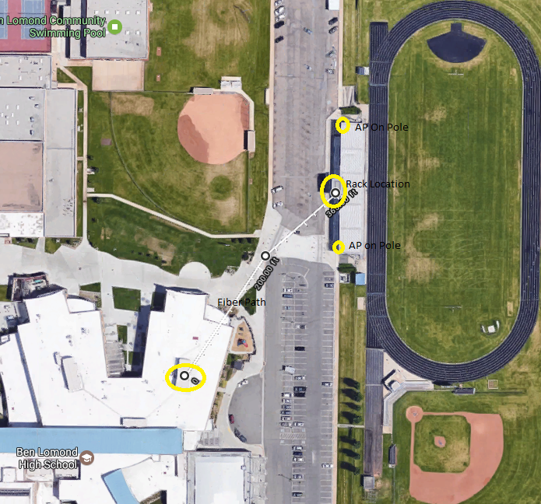

Soccer Complex Field Installation Map

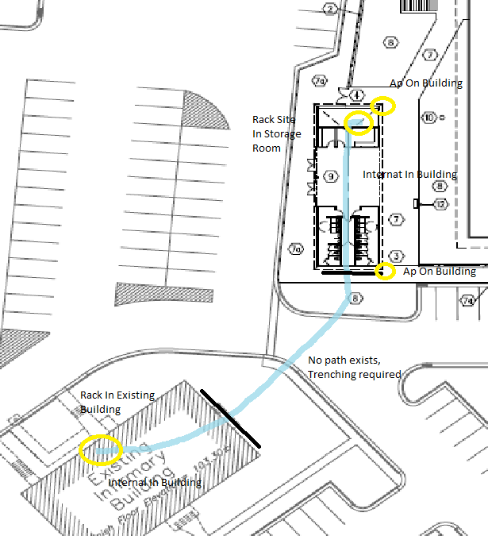

AP Installation Example 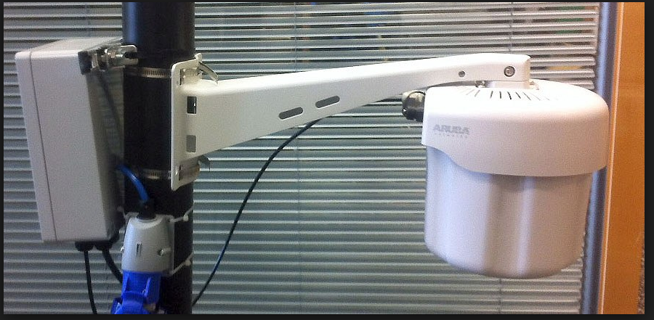
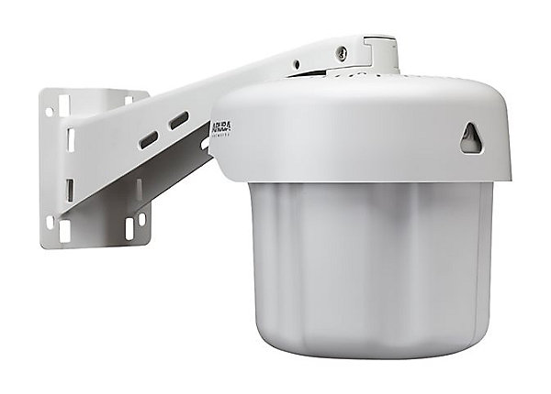

D. Proposal Considerations:
Respondents should give consideration to the following in putting together their proposal:

- Demonstrated ability: The responder will have demonstrated the ability of completing a wiring project of this size providing material in the quality and quantity requested in this RFP. Responder shall list at least 3 previous examples including references of satisfying an order relevant in size or larger.
- Time line of delivery: The responder will provide an approximate start time for the project. Project completion must occur before June 1, 2018.
- After sale support: The responder will describe their ability to support the District after the sale is completed. Specify warranty support on the wiring, installation, new equipment and other sales needs the District may have in response to this purchase.

E. Proposal Response:

Each respondent should set forth its most compelling case for being selected to provide services requested in this RFP. All proposals must be organized and tabbed with the following sections:

- Transmittal Letter & Executive Summary (2 pages Maximum)
The letter of transmittal should include: a) an introduction of the firm, including name, SPIN number, address, telephone number and email address of primary contact and others authorized to deal with this proposal response; b) A general statement of interest and what sets your firm and product apart from other potential respondents.

- Detailed Discussion
This section constitutes the major portion of the proposal and must address items delineated in Section C above and also include responses to listed items in section D above.

3. Protected / Proprietary Information
Protected information should be clearly identifiable and included in the Detailed Discussion section of the proposal. Do not incorporate protected information throughout the proposal. Rather, provide a reference in the proposal response directing readers to the specific area of this Protected Information Section.

F. Fee Proposal

(Separately Sealed) The fee proposal should include a clearly delineated cost breakdown. Any variable costs and options should be included in the fee proposal and designated appropriately.

G. Evaluation Criteria:

The proposal will be analyzed and respondents may be requested to respond to a committee of District officials for any clarifying questions regarding the RFP or proposed equipment. The District reserves the right to accept or reject any proposal. It is also the right of the District to waive any formality or technicality if determined to be in the best interest of the school district.

Evaluation Rubric

Overall qualifications, experience and references 20%
Perception of Firms Ability to Accomplish Scope of Service 20%
Fee Proposal and Fee Schedule 45%
Specified Timeline of completed project 15%

Award shall be made to the respondent deemed most capable of providing the system and support deemed to most effectively meet District needs taking into account the proposals and evaluation factors here outlined.

H. Term of Agreement:

All recommendations from the selection committee are subject to board approval.
Once the Board has approved the recommendation, the district may then enter into a contractual agreement with selected vendor. Funding of this RFP is dependent on ERATE funding and therefore, the District reserves the right to cancel all proceeding if funding is not available.

I. Due Date:

To qualify as a responsive proposal, five (5) hard copies of the proposals and one (1) electronic copy (either emailed to crawfordk@ogdensd.org or on a USB drive) of the proposal must be received by Ken Crawford, Director of Purchasing or designee, (1950 Monroe Blvd. Building #1 room 210, Ogden, Utah 84401) no later than 2:00 PM Thursday, April 20th 2017. Please reference RFP # 7-006 and Vendor Name on the package label.

